Adaptive Load Balancing Using Intelligent Routing in Computer Networks

We built and simulated this load balancer in NS-3 and compared four routing methods. When a server slows down, the Q-Learning router keeps the average response time at 42.7 ms, against 74.5 ms for plain Round Robin, a drop of about 43%.

Index
- Introduction and Problem
- Objectives
- Existing vs Proposed System
- System Architecture
- Routing Algorithms
- NS-3 Simulation Setup
- NetAnim Visualization
- Results
- Conclusion and Future Scope
- References

1. Introduction and Problem
A load balancer sits between users and a group of servers and decides which server handles each request. Most of the ones in use today follow fixed rules. Round Robin gives every server a turn in order. Weighted Round Robin gives stronger servers a bigger share, but the shares are set once and never change.
That works while every server behaves as expected. It stops working the moment one of them slows down. A fixed rule keeps sending the same share of traffic to the slow server, requests pile up in its queue, and every user routed there waits longer.
We wanted a router that notices this by itself. This project builds one in NS-3, a network simulator widely used in research, and tests it against the fixed methods under a normal run and under a run where one server slows down halfway through.

2. Objectives
- Build a working load-balancing network in NS-3 using real network components: nodes, point-to-point links, UDP traffic.
- Implement four routing methods in the same balancer so they can be compared fairly: Round Robin, Weighted Round Robin, an Adaptive heuristic and a Q-Learning agent.
- Generate realistic traffic with random, bursty request arrivals rather than a fixed rhythm.
- Slow one server down in the middle of a run and measure how each method copes.
- Compare the methods on response time, packet loss, throughput and how evenly work is spread.
- Verify the results two ways: numbers from NS-3's FlowMonitor, and a visual check in NetAnim.

3. Existing vs Proposed System
Aspect | Existing (static) methods | Proposed (intelligent) methods
How a server is chosen | Fixed turn order or fixed weights | Live queue length and in-flight requests, or a learned Q-value
Reaction to a slow server | None, the same share keeps arriving | Traffic shifts away within the run
Needs manual tuning | Weights set by hand in advance | The agent learns from response times
Uses network feedback | No | Yes, from the NS-3 device queues and measured response times
Behaviour in our failure test | Round Robin 74.5 ms, Weighted RR 87.1 ms | Adaptive 47.3 ms, Q-Learning 42.7 ms

4. System Architecture
The network is a star. One load balancer sits in the middle, the clients connect to it on one side, and three backend servers of different strength connect on the other. The balancer works like a reverse proxy: it receives a request, picks a server, forwards the request, waits for the answer and passes it back to the right client.
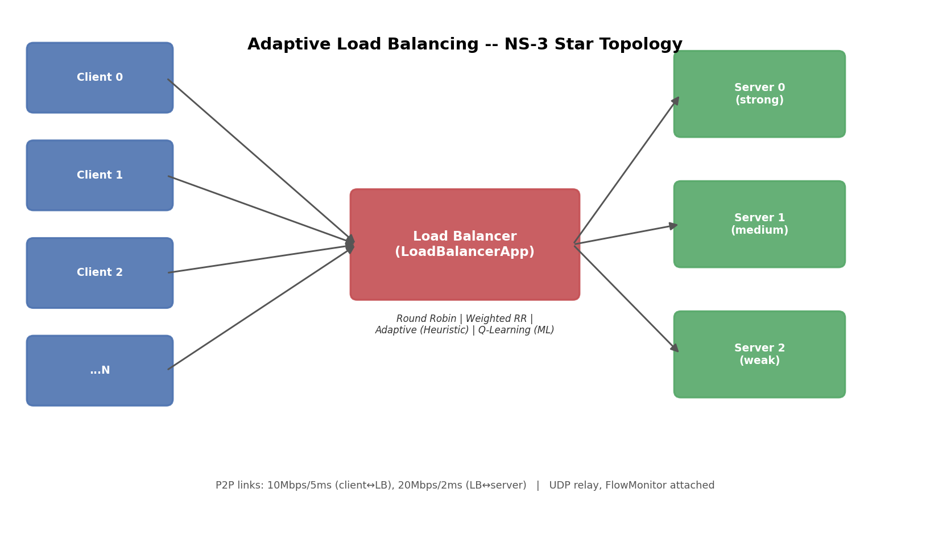
One request travels like this:
- A client sends a UDP request to the load balancer. Each request carries a 4-byte ID so the balancer can match the reply later.
- The balancer runs the active routing method and picks a server.
- The chosen server takes the request, works on it for a random service time, and sends a response.
- The balancer relays the response to the client that asked.
- The client records how long the whole round trip took. With Q-Learning active, the balancer also uses that time to update what it has learned.

5. Routing Algorithms
All four methods live inside the same LoadBalancerApp class and are chosen with one command-line flag, so the only thing that changes between runs is the decision rule.
Round Robin. Servers get requests one after another in a fixed order. Simple and fair on paper, but it ignores how strong or how busy each server is.
Weighted Round Robin. Each server gets a share in proportion to its declared capacity (60, 45 and 30 requests per second). The weights are fixed at the start, so they do not move when a server slows down.
Adaptive (heuristic). For every request the balancer reads the real queue length on the NS-3 link towards each server and counts how many requests that server has not yet answered. It scores each server as:
score = 10 \times queueLength + activeConnections
and sends the request to the server with the lowest score.
Q-Learning (machine learning). The balancer learns which server to pick from experience, with no hand-set rule for failures.
- State: the congestion level of every server (low, medium or high), combined into one number.
- Action: which server receives the next request.
- Reward: the negative of the response time, so faster answers score higher.
After each completed request the Q-table is updated with the standard rule:
Q(s,a) \leftarrow Q(s,a) + \alpha \left[ r + \gamma \max_{a'} Q(s',a') - Q(s,a) \right]
To keep exploring early on, the agent picks a random server with probability epsilon, and epsilon shrinks as it gains experience.
Setting | Value
Learning rate (alpha) | 0.3
Discount factor (gamma) | 0.5
Starting exploration rate (epsilon) | 0.3
Epsilon decay per decision | 0.995
Minimum epsilon | 0.05

6. NS-3 Simulation Setup
Every result in this report comes from the same setup, run once per routing method and once per scenario, eight runs in total.
Parameter | Value
Simulator | NS-3 (C++), custom Application classes
Topology | Star: 1 load balancer, 8 clients, 3 servers
Client to balancer link | 10 Mbps, 5 ms delay
Balancer to server link | 20 Mbps, 2 ms delay
Server capacity | 60, 45 and 30 requests per second (strong, medium, weak)
Traffic | UDP, Poisson arrivals, 10 requests per second per client
Simulation length | 40 seconds
Failure scenario | Server 0 drops to 3 requests per second from 14 s to 28 s, then recovers
Measurements | Application response time, ns3::FlowMonitor delay, loss and throughput, requests routed per server
The failure is injected by lowering the processing rate of the strongest server, since the packets themselves are tiny and cutting link bandwidth had almost no effect.

7. NetAnim Visualization
Numbers alone do not show that packets really move through the network, so we also ran the simulation with NetAnim, the animation tool that ships with NS-3. The screenshots below were taken from our own machine. The animation uses a lighter demo configuration with 6 clients so that individual packets are easy to follow.
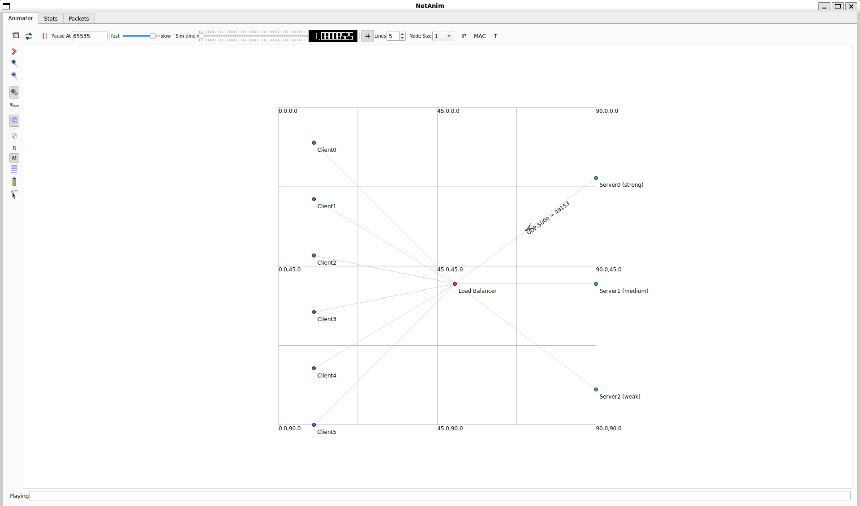
The topology close-up shows what each element is:
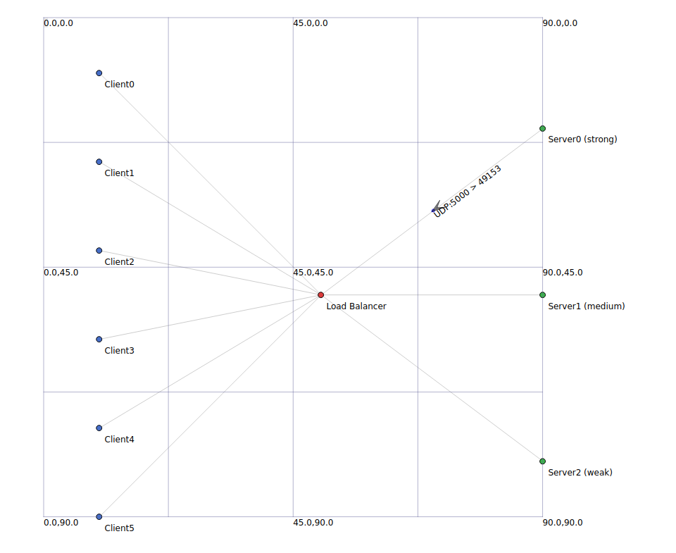
What you see | What it is
Blue dots, Client0 to Client5 | The users sending requests
Red dot, Load Balancer | The router that picks a server for every request
Green dots, Server0 (strong), Server1 (medium), Server2 (weak) | The backend servers, labelled by capacity
Thin lines | The point-to-point network links
Arrow with the label UDP:5000 > 49153 | A real packet in transit, with its protocol and ports
The animation file is generated by the simulation itself, so every packet on screen is one the simulator actually produced. When the failure scenario is played, Server0 turns red and is labelled SLOW for the duration of the slowdown.
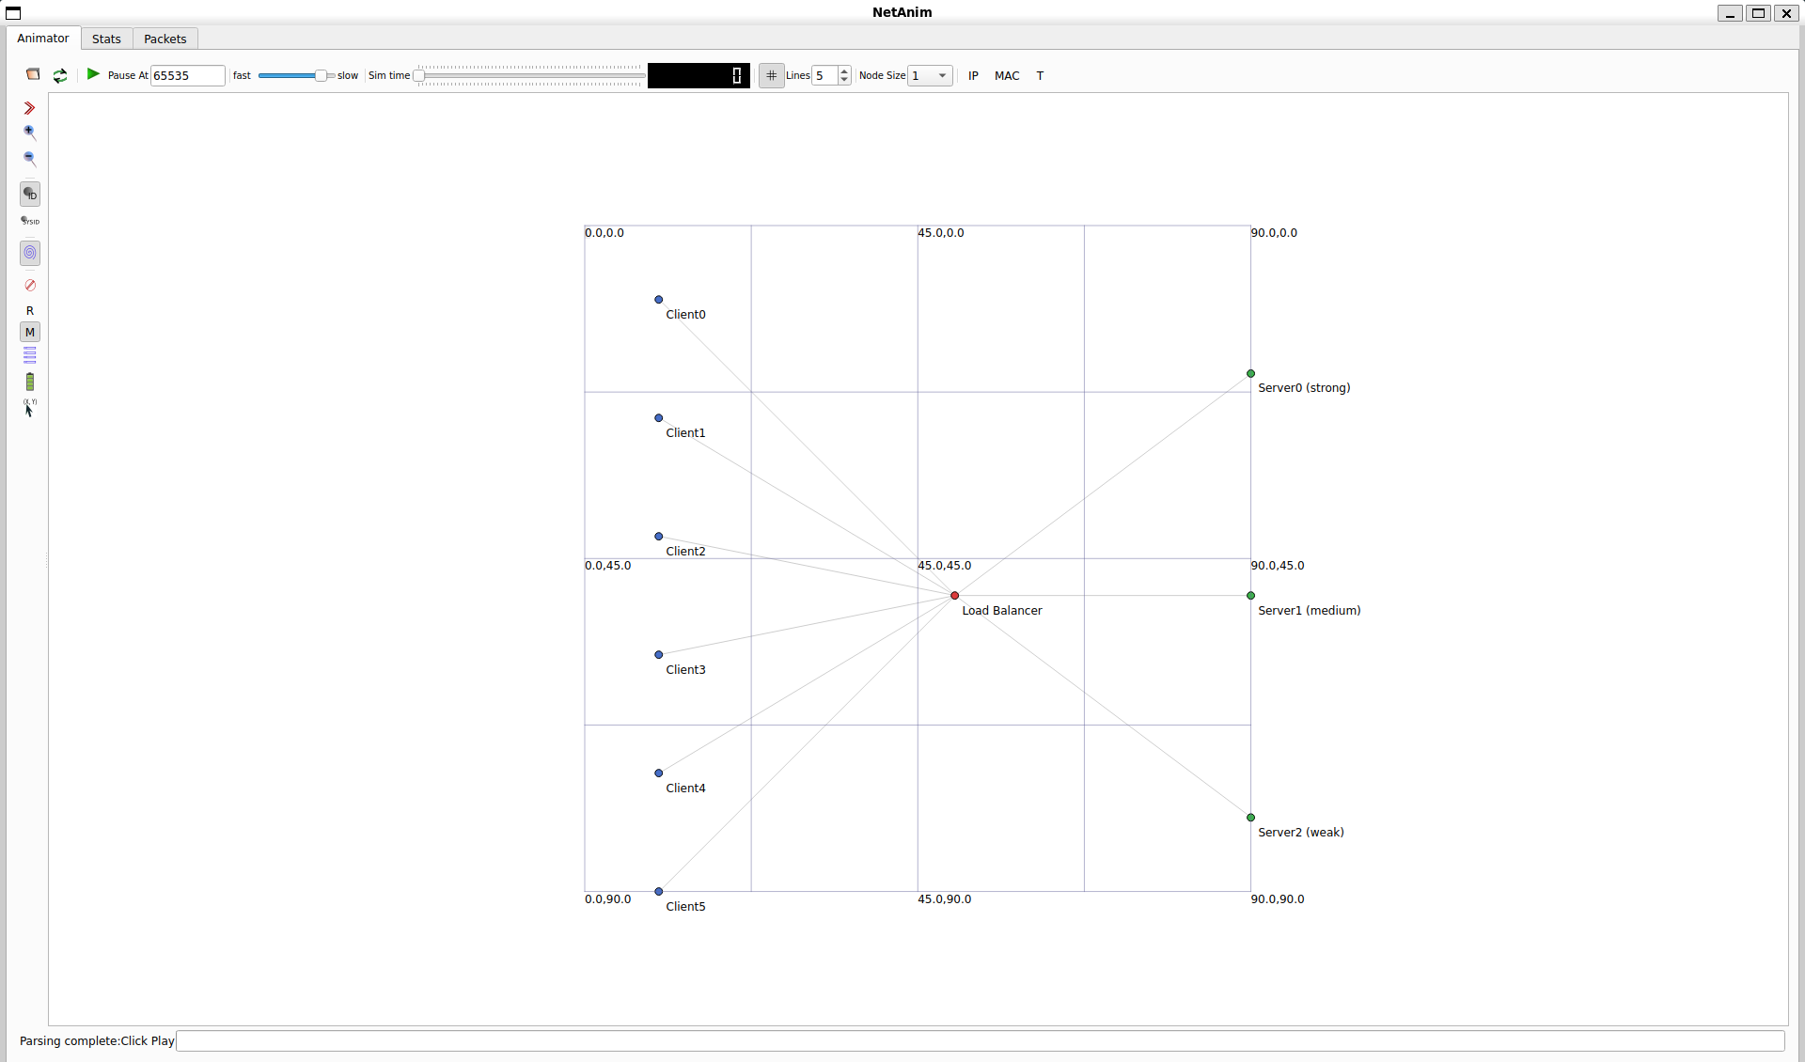

8. Results
The learning-based router gave the lowest response time in both scenarios, and the gap widens sharply once a server slows down.
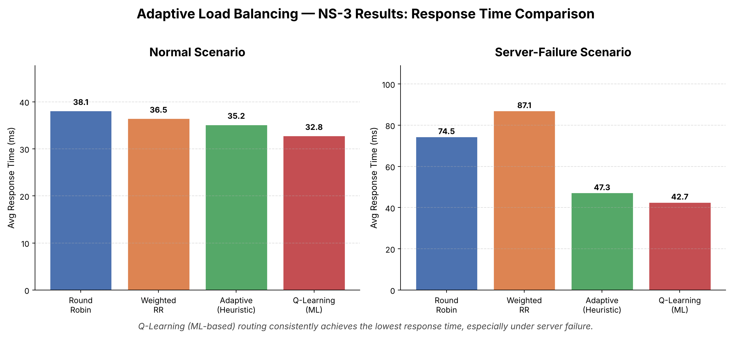
In the normal run the differences are modest: Q-Learning is about 14% faster than Round Robin (32.8 ms against 38.1 ms). In the failure run Round Robin climbs to 74.5 ms and Weighted Round Robin to 87.1 ms, while Adaptive holds at 47.3 ms and Q-Learning at 42.7 ms.
Weighted Round Robin ends up worse than plain Round Robin in the failure run. Its weights still say Server0 is the strongest, so it keeps sending Server0 the biggest share even while Server0 is crawling.
The load distribution shows why. During the failure run Q-Learning sent 792 requests to Server0, 1,947 to Server1 and 398 to Server2. It moved most of the traffic to the healthy medium server on its own, which is exactly what a human operator would do. Round Robin kept splitting the load almost evenly, at 1,046, 1,046 and 1,045.
Packet loss stayed below 0.07% and throughput was about 78 responses per second for every method, so the gain comes from smarter placement of requests, not from dropping traffic.
The full four-panel charts, with packet loss, throughput and requests per server, are below.
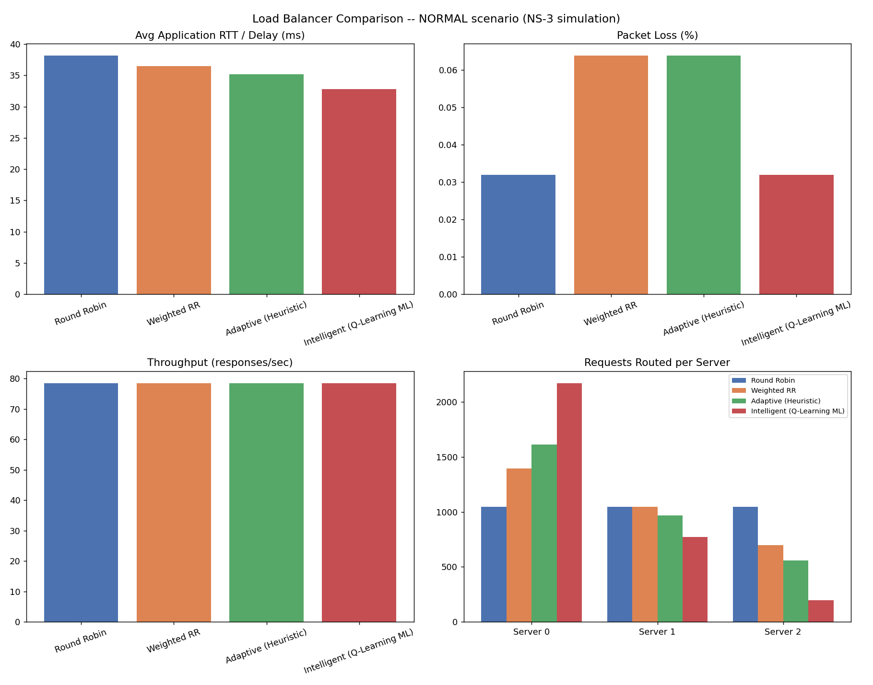
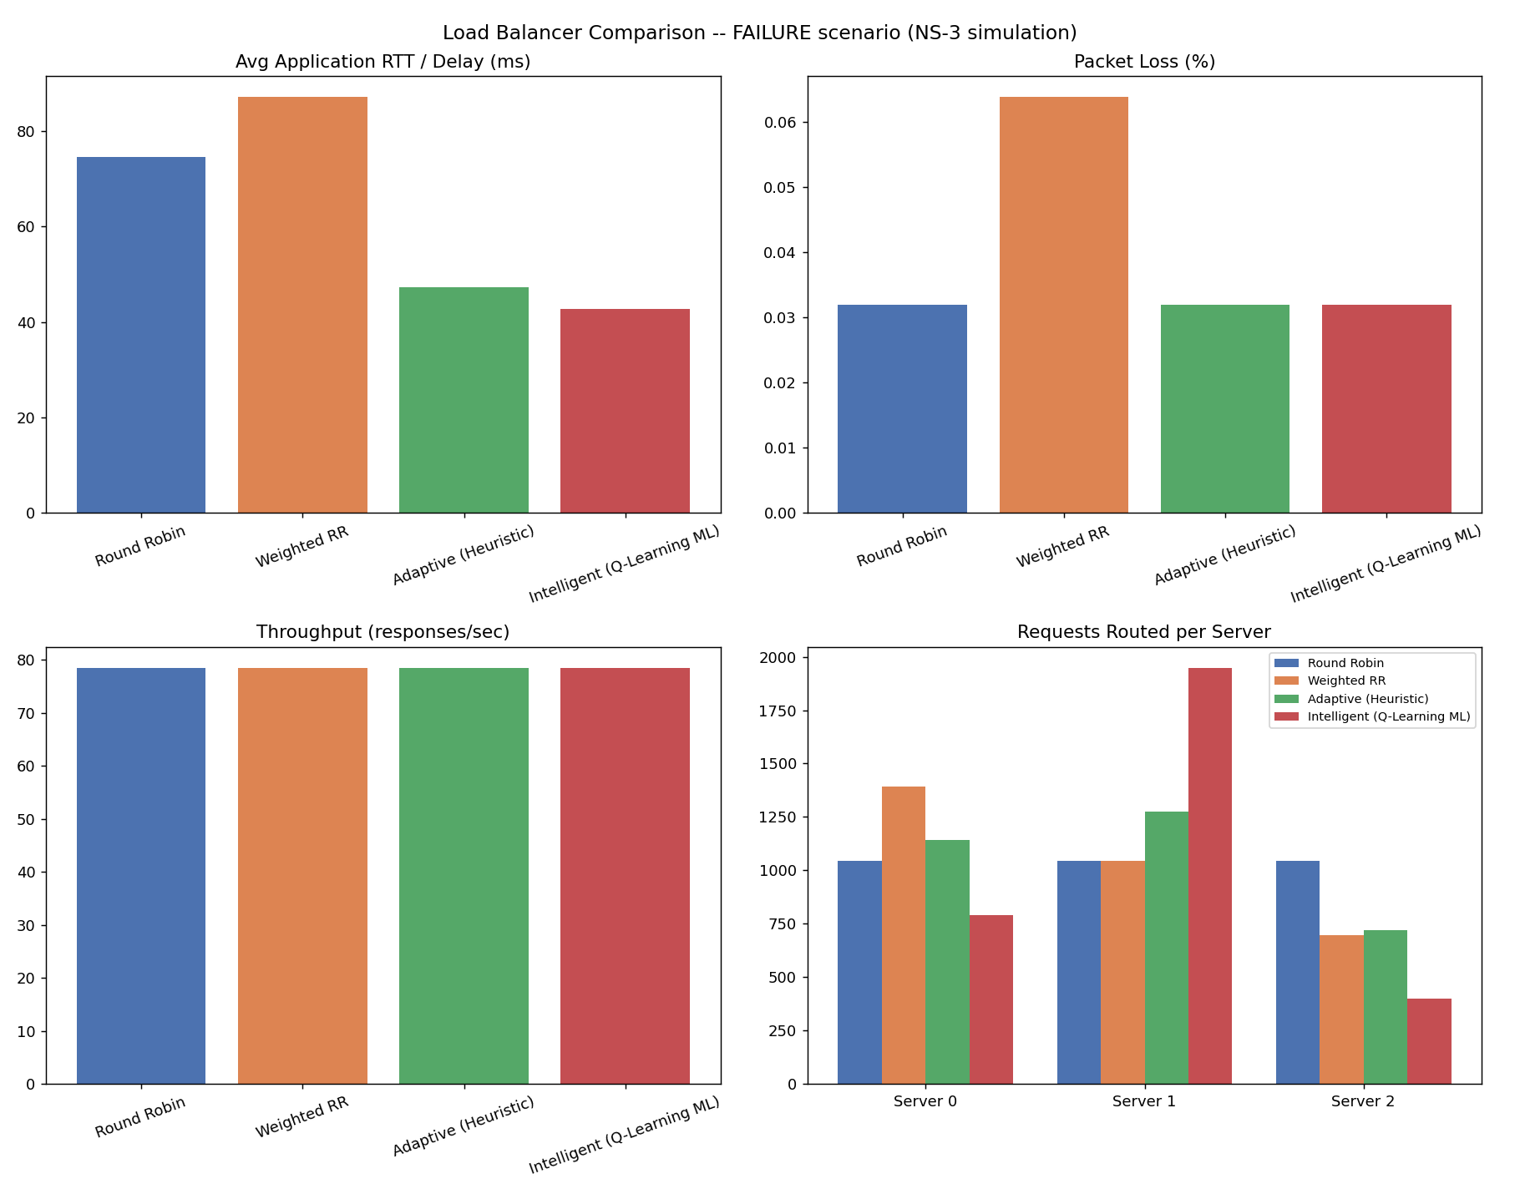

9. Conclusion and Future Scope
The project shows that a balancer which reads live feedback beats one that follows fixed rules, and that the advantage is largest exactly when it matters, when a server degrades. Q-Learning learned this from response times alone, with no rule telling it which server had failed.
Some limits are worth stating. The results come from one simulated topology with three servers and a single injected slowdown, and each configuration was run once. The Q-table is small and discrete, and the failure is a slowdown, not a full server crash.
Possible next steps:
- Repeat each run with several random seeds and report averages with spread.
- Replace the Q-table with a neural network (Deep Q-Learning) so the state can be richer.
- Add more servers, bigger topologies and full server crashes.
- Test with real TCP traffic and application-level request sizes.
- Port the idea to a software-defined network controller.

10. References
- C. J. C. H. Watkins and P. Dayan, "Q-learning," Machine Learning, vol. 8, pp. 279-292, 1992.
- R. S. Sutton and A. G. Barto, Reinforcement Learning: An Introduction, 2nd ed., MIT Press, 2018.
- ns-3 network simulator documentation
- Source code and results for this project

